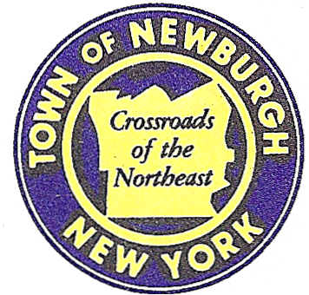

TOWN OF NEWBURGH
_______Crossroads of the Northeast __________________________
OLD TOWN HALL
308 GARDNERTOWN ROAD NEWBURGH, NEW YORK 12550

PLANNING BOARD
JOHN P. EWASUTYN, CHAIRMAN
TELEPHONE 845-564-7804
FAX 845-564-7802
E-MAIL: planningboard@townofnewburgh.org

PLANNING BOARD AGENDA

November 16th, 2017

*PLEASE NOTE: The Planning Board Meeting will start at 7:00 P.M. and all Applicants/Representatives
are to be present at that time. The Meeting will be held in the Meeting Room of Town Hall,
located at 1496 Route 300, Newburgh NY.*

- Tilson Lot Line Change (17-27) INITIAL APPEARANCE
North Plank Rd.—NYS Rt. 32 LOT LINE CHANGE
Section 42, Block 1, Lot 2.22 & 3
Zone: R3
Rep: Vincent Doce & Associates
242 South Plank Rd.
Newburgh, NY 12550

2. Beretta Subdivision (17-21) PUBLIC HEARING
Old Post Rd. & River Rd. 2 LOT SUBDIVISION
Section 8, Block 1, Lot 38.
Zone: AR & I
Rep: Maser Consulting
555 Hudson Valley Ave. Suite 101
New Windsor, NY 12553

- Gaydos Mariani Lot Line Change (17-28) INITIAL APPEARANCE
Shady Lane & Friar Lane LOT LINE CHANGE
Section 64, Block 3, Lot 1
Zone: R3
Rep: Darrin Scalzo, Associates P.E.
57 Fifth Ave
Newburgh, NY 12550

*WORK SESSION*
Project Readiness Discussion scheduled for 5:30 p.m. in the Meeting Room of
Town Hall on Thursday, November 16th, 2017.*

PLANNING BOARD BUSINESS
WORK SESSION

- Patton Ridge Subdivision (12-18) Requesting a six month extension from November
16,2017 to May 16, 2017.

*WORK SESSION*
Project Readiness Discussion scheduled for 5:30 p.m. in the Meeting Room of
Town Hall on Thursday, November 16th, 2017.*

